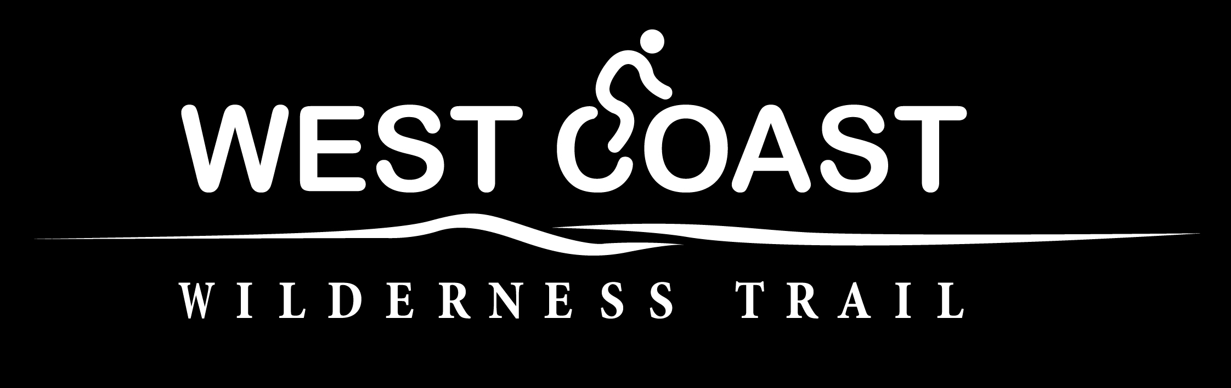

The New Zealand Cycle Trail

Official Partner Programme 2018/19

Application form and agreement

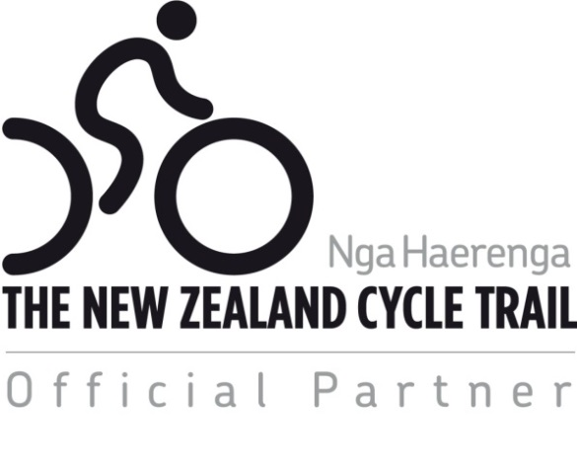

OFFICIAL PARTNER PROGRAMME – QUESTION AND ANSWERS

Why have an Official Partner Programme?
The physical trail is only one part of the overall product that will attract cyclists. In addition to a high-quality trail, cyclists require services such as transport, accommodation, bike hire, food, and activities for when they are not cycling. They expect a high level of customer service and appreciate a warm welcome.

The Official Partner Programme provides a way that your business and local trail can work together to promote the trail and attract more cyclists to your region. This will increase the turnover of your business and provide benefits and jobs to communities. To ensure that there is a consistently high level of customer service across New Zealand, you can apply to join the Official Partner Programme and be recognised as an Official Partner. To become an Official Partner your business must meet certain cycle-friendly standards.

What are the cycle-friendly criteria?
These are contained in the application form. They are simple standards based around the basic needs of cyclists. You will assess your own business.

What are the benefits to my business?
Becoming an Official Partner entitles your business to:

- Use The New Zealand Cycle Trail Official Partner logo at your establishment, on your website and in publications.
- Listing of your business on your local trail’s website, and on the New Zealand Cycle Trail website at www.nzcycletrail.com ).
- Official Partners will be invited to promote themselves as part of the official New Zealand Cycle Trail product directory that will be updated for TRENZ each year.
- Receive regular updates on cycle trail activities and opportunities and invitations to Official Partner meetings.
- Increased business referrals by encouraging cyclists to use businesses that display the Official Partner logo i.e. “support the businesses that support the trail”. When cyclists see a business displaying the Official Partner logo they will have some assurance that the business has met minimum cycle-friendly standards.

The Official Partner programme will provide a forum for your local trail and businesses to work together to increase the appeal of your local trail. The inclusion of official partner information on websites actively promoting the New Zealand Cycle Trail will be promoted. The Official Partner Programme will increase New Zealand’s credibility as a cycling destination.

How much will it cost?
The cost for the basic membership is $295+ GST per year. This membership will run through until 30 June 2018.

Who manages the Official Partner Programme?
The owner or manager of the trail manages the Official Partner Programme. All membership fees will go to your local trail. It is envisaged that the money will contribute to the maintenance, marketing and promotion of the trail. A separate National Partner Programme is managed by the New Zealand Cycle Trail.

OFFICIAL PARTNER PROGRAMME APPLICATION FORM (OPP)
If you would like to become an Official Partner, please fill out this form and submit this and the required information on the Wilderness Trail website under the tab Contact → Become an Official Partner. Details on how to submit your application are provided below.

Business Name:
Type of Business:
Contact Person:
Email address for OPPs emails:
Website:
Postal Address:
Town / City: |  | Post code:
Phone: |  | Cell phone:
Website Content – the content below will be listed on the Wilderness Trail and NZCT websites

Description of your business (60 words):
Postal Address:
Physical Address:
Phone Number:
Email Address:
Website Address:
Photo: | Please attach a photo representing your business (preferably 1000 pixels in width)
Logo: | Please attach your business logo. This also goes on the New Zealand Cycle Trail website.

Criteria for Membership of the Official Partner Programme

The following is the criteria for becoming an Official Partner of the New Zealand Cycle Trail.

By ticking the relevant boxes below you declare that you meet the corresponding cycle friendly criteria.
(Note: To tick the box, copy and paste the tick symbol in the top right cell of the form)

GUIDELINES FOR ALL BUSINESSES - REQUIRED | √
- The business sells or promotes products or services that relate to The New Zealand Cycle Trail or is a supporter of the trail.
- Complies with all laws and regulations relevant to their operation.
- Provides a quality experience and a high level of customer service for cyclists.
- Provides a warm welcome and prompt friendly service to all visitors arriving by bike.
- Staff can provide first-hand knowledge of the cycle trail and explain how to get more information.
- Information and maps of local bike trails available to cyclists.
SPECIFIC TO CYCLE-FRIENDLY ACCOMMODATION - ENCOURAGED
- Secure undercover storage for bikes is provided.
- Facilities for cleaning / washing bikes.
- Facilities for washing and drying clothes.
- Bike repair - provision of basic tools, pump, etc. and/or the contact details and opening hours for the nearest bike repair shop are known.
- Staff can organise hire bikes if requested.
SPECIFIC TO CYCLE-FRIENDLY ATTRACTION / CAFÉ - ENCOURAGED
- Bike racks or options for securing bikes to stands etc. are available (for riders to use their bike locks).
- There is free drinkable water.
- For cafes only: Provide food and drinks suitable for hungry/thirsty cyclists.
SPECIFIC TO CYCLE-FRIENDLY TRANSPORT GUIDELINES - REQUIRED
- Bikes are transported in a safe and secure manner without any damage.
- Provide a reliable and punctual service.
- Provide a “rider intentions” service for the safety of cyclists who will be riding in remote areas.

Joining Up

Official Partner membership benefits | Cost
Becoming an Official Partner entitles the business to:  - Use The New Zealand Cycle Trail Official Partner logo at your establishment, on your website and in publications.  - Listing of your business on your local trail’s website and on the New Zealand Cycle Trail website at www.nzcycletrail.com).  - Official Partners will be invited to promote themselves as part of the official New Zealand Cycle Trail product directory that will be updated for TRENZ each year.  - Receive regular updates on cycle trail activities and opportunities and invitations to Official Partner meetings.  - Increased business referrals by encouraging cyclists to use businesses that display the Official Partner logo i.e. “support the businesses that support the trail”. When cyclists see a business displaying the Official Partner logo they will have some assurance that the business has met minimum cycle-friendly standards. | $295+GSTpa

Payment:
You can pay the membership fee via credit card or internet banking when you submit your application online.

Submitting your application for membership:

- Please check that you have completed all the above sections of this application form before uploading to the website.

- Save the Word version of your form then save this as a PDF. (Note: to save as a PDF click Save As and under the Save as type option click PDF).

- Sign the form in the boxes below. If you are submitting your application online, you do not need to sign this form. Submitting your application will be considered as agreeing to the terms of the Official Partnership Programme.

- Upload the PDF version to the West Coast Wilderness Trail with the rest of your information.

- Please retain a copy for your records. These terms and conditions will form the legally binding agreement between The West Coast Wilderness Trail Trust and yourself in the event that your application is successful.

- Once the West Coast Wilderness Trail Trust has received your completed application, it will notify you whether your application has been successful. Please note that it is at the West Coast Wilderness Trail’s discretion whether to grant you a licence or not.

- If your application has been successful, you will be sent a copy of the Official Partner logo, details on how to download the logo and accompanying guidelines, and a receipt for payment.

- PLEASE NOTE that your licence will expire on 30 June 2019 and invoices will be issue for the 2019/20 year. If you do not wish to continue being an Official Partner after this date, please notify the West Coast Wilderness Trail Trust accordingly via email to wildernesstrailtrust@gmail.com.

- If your application has not been successful, you will be notified and your payment will be refunded.

IMPORTANT: By signing this application form, you declare that:

- you are authorised to make this application on behalf of your business;

- all the information provided by you in this form is true and correct;

- you will notify the West Coast Wilderness Trail Trust if any details provided by you in this form change;

- you agree to the attached licence terms and conditions in the event that your application is successful.

Signed:
Name:
Title:
Date:

Official Partner Licence Agreement
Terms and Conditions

- Licence Agreement

This agreement is between you and the West Coast Wilderness Trail Trust (the licensor).The licensor has the right to licence the use of the New Zealand Cycle Trail Official Partner logo (the logo) on behalf of its owner, the Ministry of Business, Innovation and Employment (MBIE).

- Grant of Licence

2.1 In consideration of you paying the licence fee (as specified in the application form), the licensor grants you a non-exclusive non-transferable licence to use the logo in relation to the marketing or promotion of cycle trail related products and/or services.

2.2 This licence is effective from the date that the licensor notifies you that your application has been successful until the end of the financial year for which the licence has been issued.

- Restrictions

3.1 You may only use the logo at your establishment and on your vehicles, equipment (e.g. bikes) and your website, brochures, posters, newsletters, business cards and letterhead.

3.2 You must comply with all guidelines issued by the licensor for use of the logo (which may be updated by the licensor at any time).

3.3 You must not:
- use the logo on saleable merchandise e.g. souvenirs; or
- allow anyone else to use the logo; or
- alter the logo in any way.

3.4 If MBIE amends or updates the logo, the licensor will notify you and provide you with the amended or updated logo and you will use that logo instead of the previous version.

- Expiry or Termination

4.1 The licensor may terminate this licence immediately by giving you notice if you:
- no longer meet all the criteria for membership of the Official Partnership Programme; or
- breach any condition of this agreement; or
- do anything that damages (or may damage) the reputation of the New Zealand Cycle Trail or its brand or the licensor or MBIE.

4.2 In the event that this agreement is terminated for any reason, the licence fee will not be refunded.

4.3 On expiry or termination of this agreement, you must immediately cease all use of the logo (unless and until a new licence has been granted).

- Miscellaneous
This agreement is governed by New Zealand law.

